**SQL Queries**

1) Write a query for the HR department to produce the addresses of all the departments.

Use the LOCATIONS and COUNTRIES tables. Show the location ID, street address,

city, state or province, and country in the output. Run the query



2) The HR department needs a report of employees in Toronto. Display the last name, job,

department number, and department name for all employees who work in Toronto.



3) Create a report for HR that displays the last name and salary of every employee who reports to

King.



4) Create Table MY_EMPLOYEE. Description is shown below:

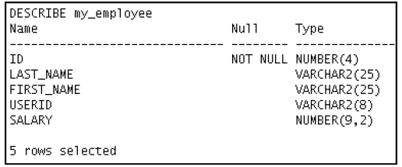

5) Add the following data to the MY_EMPLOYEE table

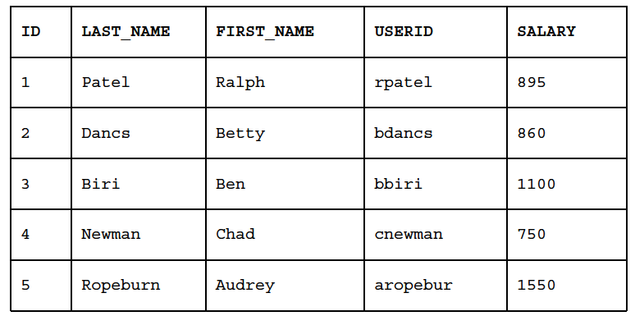

6) Change the last name of employee 3 to Drexler.

7) Change the salary to $1,000 for all employees who have a salary less than $900.

8) Delete Betty Dancs from the MY_EMPLOYEE table.

9) Mark an intermediate point in the processing of the transaction.

10) Delete all the rows from the MY_EMPLOYEE table. Confirm that the table is empty.

11) Discard the most recent DELETE operation.

12) Make the data addition permanent.

13) The staff in the HR department wants to hide some of the data in the EMPLOYEES table. Create

a view called EMPLOYEES_VU based on the employee numbers, employee last names, and

department numbers from the EMPLOYEES table. The heading for the employee name should be

EMPLOYEE.

Confirm that the view works. Display the contents of the EMPLOYEES_VU view